This is a trivia game I created for one my singles ministries. I got several of the questions and answers online as well as created my own questions and answers. These questions are easily changeable to meet a particular theme or direction that you might be going. There are also thousands of Bible trivia questions and answers online.

Instructions: We printed out each set of questions that went with each photograph or image and put it on the wall. We divided our folks into groups of 3, trying to have a man in each team (you can opt for more but some end up not talking while others do all the talking). We also were sensitive to make sure we didn’t put 3 new Christians together. They had a regular notepad and went in whatever order they wanted, writing down the answers they came up with per number. We gave them a point for each complete answer—even with questions that asked for more than one answer—we gave them points. Note: You could put the questions on a sheet but then folks have a tendency to sit down and not look at the images. Another option would be for folks to answer questions by looking at the images. Note: You could create a sheet with the numbers 1-15 on them.

We timed the game for 20 minutes, which seemed to work pretty good. You may have to vary this depending on the size group you have.

The value of putting the sheets on the wall is you move, you can hear others talk, you engage, and its so much fun.

We gave the winning team some cool scripture cards..something that adds to learning vs. candy. Everyone seemed to enjoy.

While I appreciate a nod for putting this together (www.TheSinglesNetwork.org ministries, to help keep our ministry going and growing). It is not necessarily as the Bible was my source and the internet for the images.

QUESTIONS/ANSWER SHEET
Flyer 1:
Q. How many books are in the Bible? A: Old Testament: 39; New Testament: 27
Q. How many brothers and sisters did Joseph have? A. 11 brothers. He also had 1 sister.
Q: What were Joseph’s parent’s names? A: Jacob and Rachel
Q: What were Joseph’s sibling’s names? A: Reuben, Simeon, Levi, Judah, Issachar, Zebulon, Dan, Naphtali, Gad, Asher, Benjamin, Dinah

Flyer 2:
Q. Noah sent out 2 different kinds of birds from the Ark. What were they? A. Raven and Dove
Q: Who did Noah bring with him on the Ark? A: Shem, Ham and Japheth (and their wives)

Flyer 3:
Q. Abraham traveled with his nephew. What was his nephew’s name? A: Lot
Q: What happened to his wife? A: Turned to a pillar of salt
Q: What cities were destroyed and why? A: Sodom and Gomorrah

Flyer 4:
Q. Who found baby Moses in the river? A. Pharaoh’s daughter
Q: What was Moses nationality? A: Hebrew
Q: What was Moses biological sister’s name? A: Miriam
Q: What was Moses wife’s name? A: Zippora
Q: What was Moses father in law name? A: Jethro
Q. What was the name of the mountain where Moses was given the 10 Commandments? A. Mt. Sinai

Flyer 5:
Q: What are the 10 Commandments?
1) “You shall have no other gods before me.”, 2) “You shall not make for yourself an idol
3) “You shall not misuse the name of the LORD your God,
4) “Remember the Sabbath day by keeping it holy.
5) “Honor your father and your mother, 6) “You shall not murder.”
7) “You shall not commit adultery.” 8) “You shall not steal.”
9) “You shall not give false testimony against your neighbor.”
10) “You shall not covet your neighbor's house.

Flyer 6:
Q: What are the names of the 12 disciples? A: Andrew, Bartholomew or Nathanaelm, James, James, John, Judas, Jude or Thaddeus, Matthew or Levi, Peter or Simon Peter, Philip, Simon, Thomas

Flyer 7:
Q: How many times did Daniel pray each day? A: 3
Q: Who took Daniel and others captive? A: King Nebuchadnezzar
Q: What did Daniel do for the King? A: Interpret his dreams
Q: Why was Daniel thrown into the Lion’s Den?
A: Because he prayed when there was a decree not to pray for 30 days. It was an attempt to get him into trouble, to get rid of him, falsely accuse.
Q: What happened in the Lion’s Den? A: God saved him
Q: What happened to Daniel's enemies after Daniel was freed from the lion's den?
A: They were thrown into the lion’s den

Flyer 8: Q: How many wings on a Seraphim? A: 6
Q: What did they wings cover? A With two wings they covered their faces, with two they covered their feet, and with two they were flying.
Q: What is the purpose of a Seraphim? A: Seraphs are angels who worship God continually.

Flyer 9:
Q: Which is the shortest book in the Bible?
A: 2nd Epistle of John (by number of verses: 13) 3rd Epistle of John (by number of words)
Q: Which is the longest book in the Bible? A: Psalms (150 Chapters)

Flyer 10:
Q. What river was Jesus baptized in? A. Jordan River
Q: Who was Jesus’ cousin’s name? A: John the Baptist
Q. What was the first miracle of Jesus recorded in the Bible? A. Turning the water into wine.
Q: How many others can you list?
-Jesus Heals an Official's Son
-Jesus Drives Out an Evil Spirit
-Jesus Heals Peter's Mother-in-Law
-Jesus Heals Many Sick at Evening
-First and Second Miraculous Catch of Fish
-Jesus Cleanses a Man With Leprosy
-Jesus Heals a Centurion's Servant
-Jesus Heals a Paralytic
-Jesus Heals a Man's Withered Hand
-Jesus Raises a Widow's Son in Nain
-Jesus Calms a Storm
-Jesus Casts Demons into a Herd of Pigs
-Jesus Heals a Woman in the Crowd
-Jesus Raises Jairus' Daughter to Life
-Jesus Heals Two Blind Men
-Jesus Heals a Man Unable to Speak
-Jesus Heals an Invalid at Bethesda
-Jesus Feeds 4, 000 and 5,000
-Jesus Walks on Water
-Jesus Heals Many Sick in Gennesaret
-Jesus Heals a Gentile Woman's Demon-Possessed Daughter
-Jesus Heals a Deaf and Dumb Man
-Jesus Heals a Blind Man at Bethsaida
-Jesus Heals a Man Born Blind
-Jesus Heals a Boy with a Demon
-Miraculous Temple Tax in a Fish's Mouth
-Jesus Heals a Blind, Mute Demoniac
-Jesus Heals a Crippled Woman
-Jesus Heals a Man With Dropsy on the Sabbath
-Jesus Cleanses Ten Lepers
-Jesus Raises Lazarus from the Dead
-Jesus Restores Sight to Bartimaeus
-Jesus Withers the Fig Tree
-Jesus Heals a Servant's Severed Ear

Flyer 11
Q. What kind of work did Zacchaeus do? What he is known for? A. Tax collector
Q: What did Zacchaeus do to see Jesus? A: Climb up in a Sycamore tree
Q: Where was Jesus going with Zacchaeus? A: His home

Flyer 12
Q. When Jesus was on the Mount of Transfiguration, who were the Old Testament men who appeared with Him? A. Moses and Elijah
Q: Who did Jesus take with him to the Mountain? A: Peter, James and John
Q: What did God say about Jesus at this time? A: “This is My Son, whom I love; with Him I am well pleased. Listen to Him!”

Flyer 13
Little House on the Prairie often shared Christian beliefs and story lines.
Q: What are the names of the Ingalls’s biological family?
A: Charles, Carolina, Laura, Mary, Carrie, Grace
Q: What was the name of the Reverend? A: Robert Alden
Q: Where was the church located in Walnut Grove? A: In the Schoolhouse

Flyer 14
The Walton’s often shared their Christian beliefs and story lines.
Q: What are the names of the Walton family that lived in the white house?
Jim Bob, Elizabeth, Maryellen, John Boy, Erin, Ben, Jason, John, Olivia, Grandma Ester and Grandpa Zeb
Q: Who was the Narrator of the Walton’s? A: Earl Hammer, JR
Q: Who was one of the Walton’s’ Reverends? A: John Ritter
Q: Who did the Reverend ask to preach a sermon too while he was on his honeymoon?
A: John Boy
Q: Who tried to help this person by writing a sermon? A: Grandma Ester

Flyer 15
In many episode’s, Andy Griffith shared Christian themes and storylines.
Q: What are the names of some of the main characters from the show?
Andy Taylor, Bee Taylor, Opie Taylor, Barney Fife, Helen Crump, Howard Sprague, Otis Campbell, Goober and Golmer Pyle, Floyd Lawson, Thelma Lou, Ellie Walker, Mayor Pike
Q: Who played the piano in the church? A: Clara Edwards
Q: What church song was sung by Barney and Andy on the front steps? A: Church in the Wildwood
Q: In the 4th season, a traveling preach named Dr. Breen delivers a sermon called ‘The Sermon for Today”…what was it about?
A: Being in such a hurry

Flyer 1
Q:. How many books are in the Bible (old and new)?

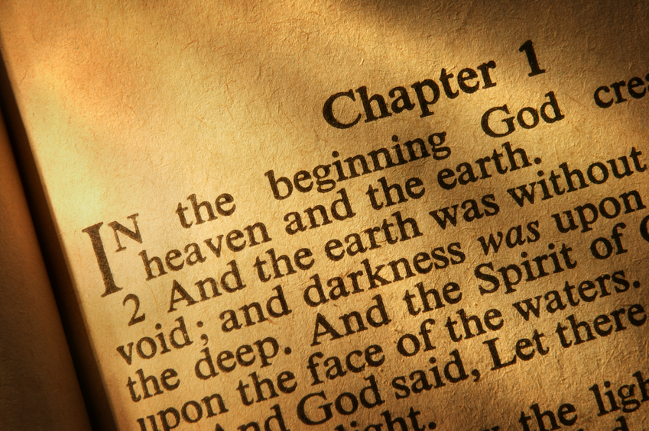

Flyer 2:
Q. How many brothers and sisters did Joseph have?
Q: What were Joseph’s parent’s names?
Q: What were Joseph’s sibling’s names?

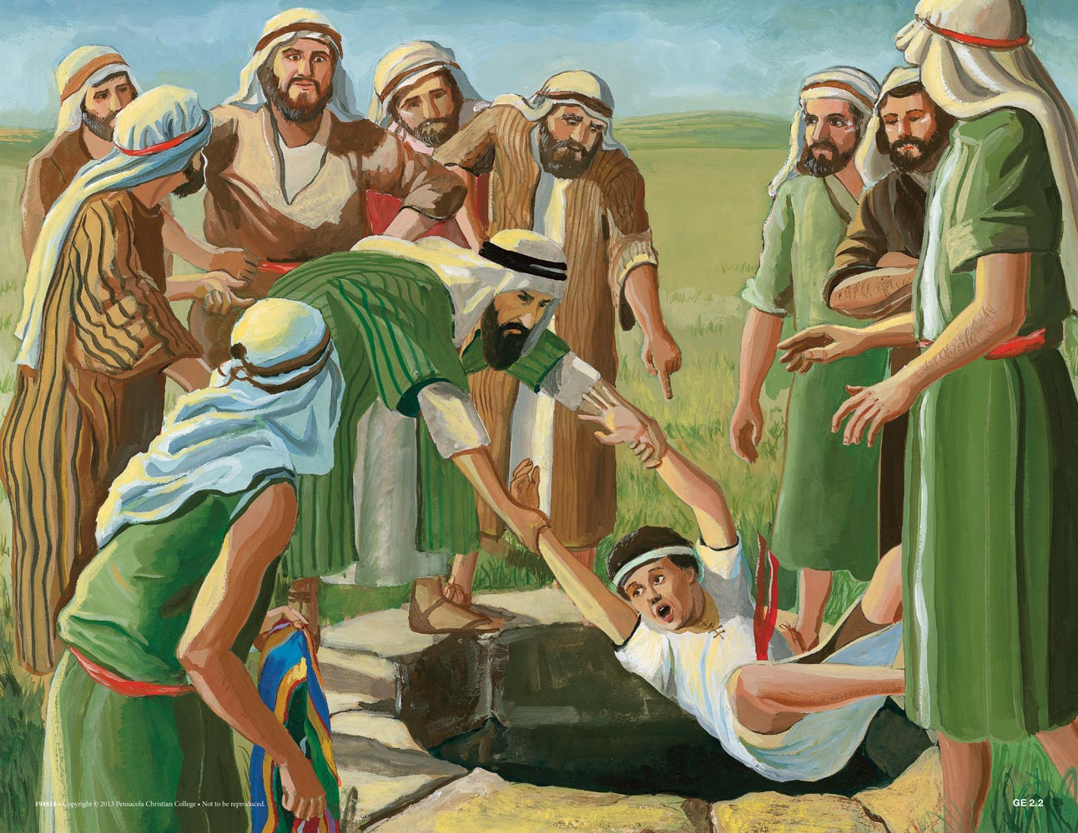

Flyer 3
Q. Noah sent out 2 different kinds of birds from the Ark. What were they?
Q: Who did Noah bring with him on the Ark?

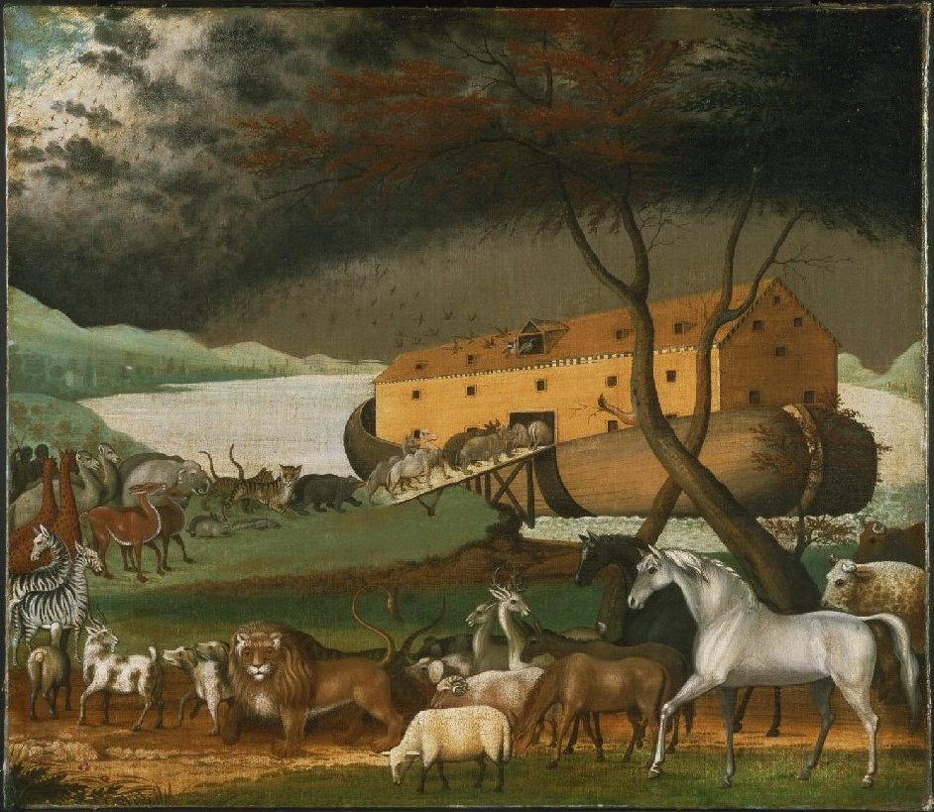

Flyer 4
Q. Abraham traveled with his nephew. What was his nephew’s name?
Q: What happened to his wife?
Q: What cities were destroyed and why?

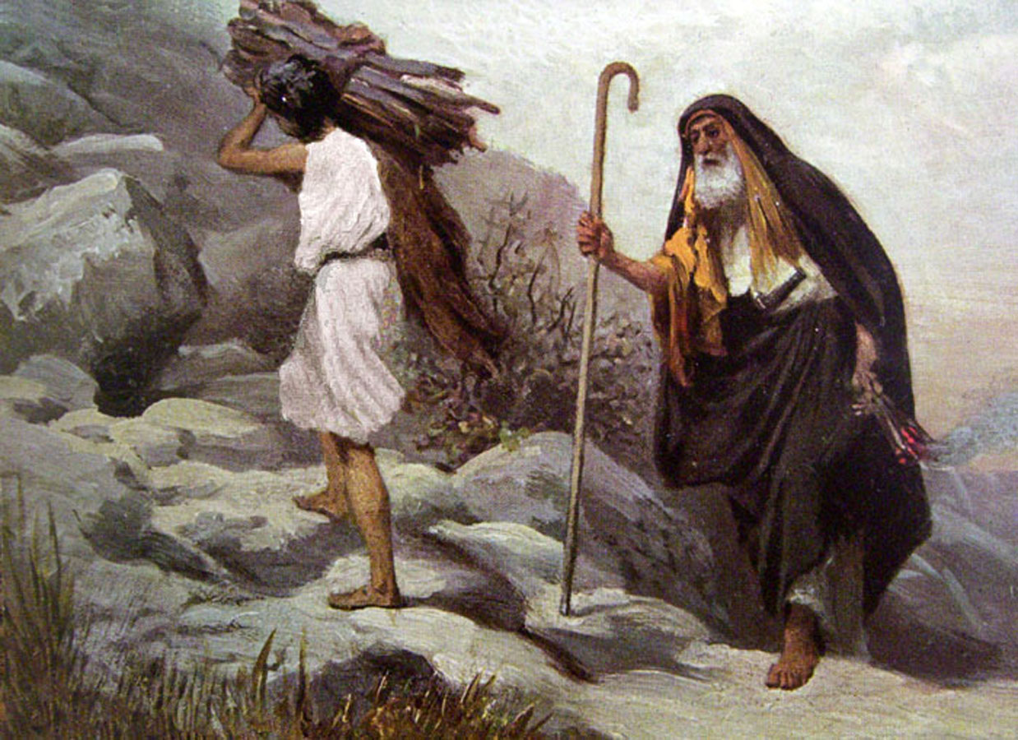

Flyer 5
Q. Who found baby Moses in the river?
Q: What was Moses nationality?
Q: What was Moses biological sister’s name?
Q: What was Moses wife’s name?
Q: What was Moses father in law name?
Q. What was the name of the mountain where Moses was given the 10 Commandments?
Q: What are the 10 Commandments?

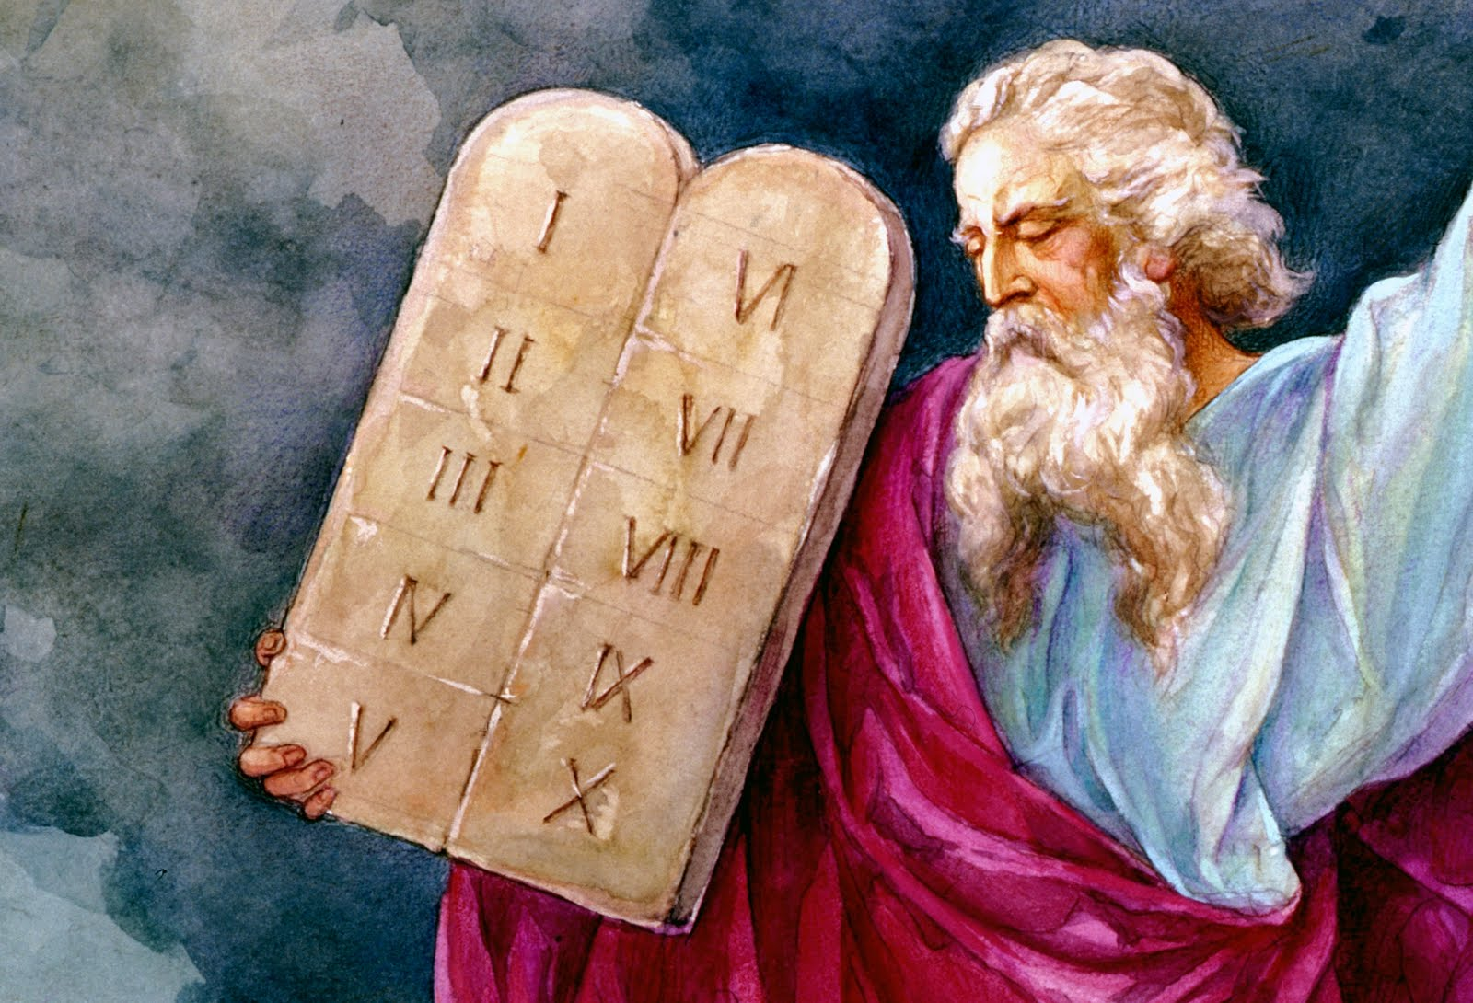

Flyer 6
Q: What are the names of the 12 disciples?

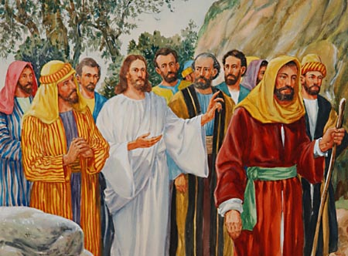

Flyer 7
Q: How many times did Daniel pray each day?
Q: Who took Daniel and others captive?
Q: What did Daniel do for the King?
Q: Why was Daniel thrown into the Lion’s Den?
Q: What happened in the Lion’s Den?
Q: What happened to Daniel's enemies after Daniel was freed from the lion's den?
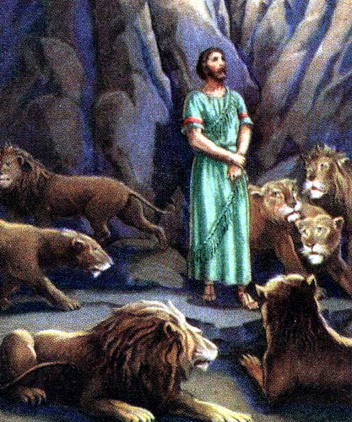
Flyer 8:
Q: How many wings on a Seraphim?
Q: What did they wings cover?
Q: What is the purpose of a Seraphim?

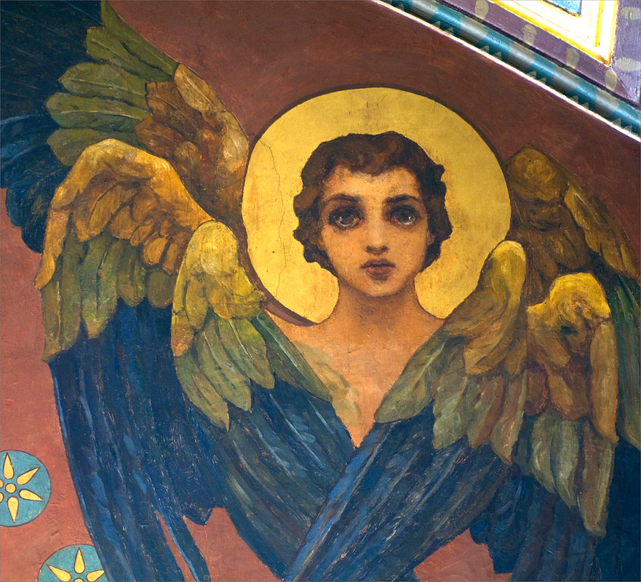

Flyer 9
Q: Which is the shortest book in the Bible?
Q: Which is the longest book in the Bible?

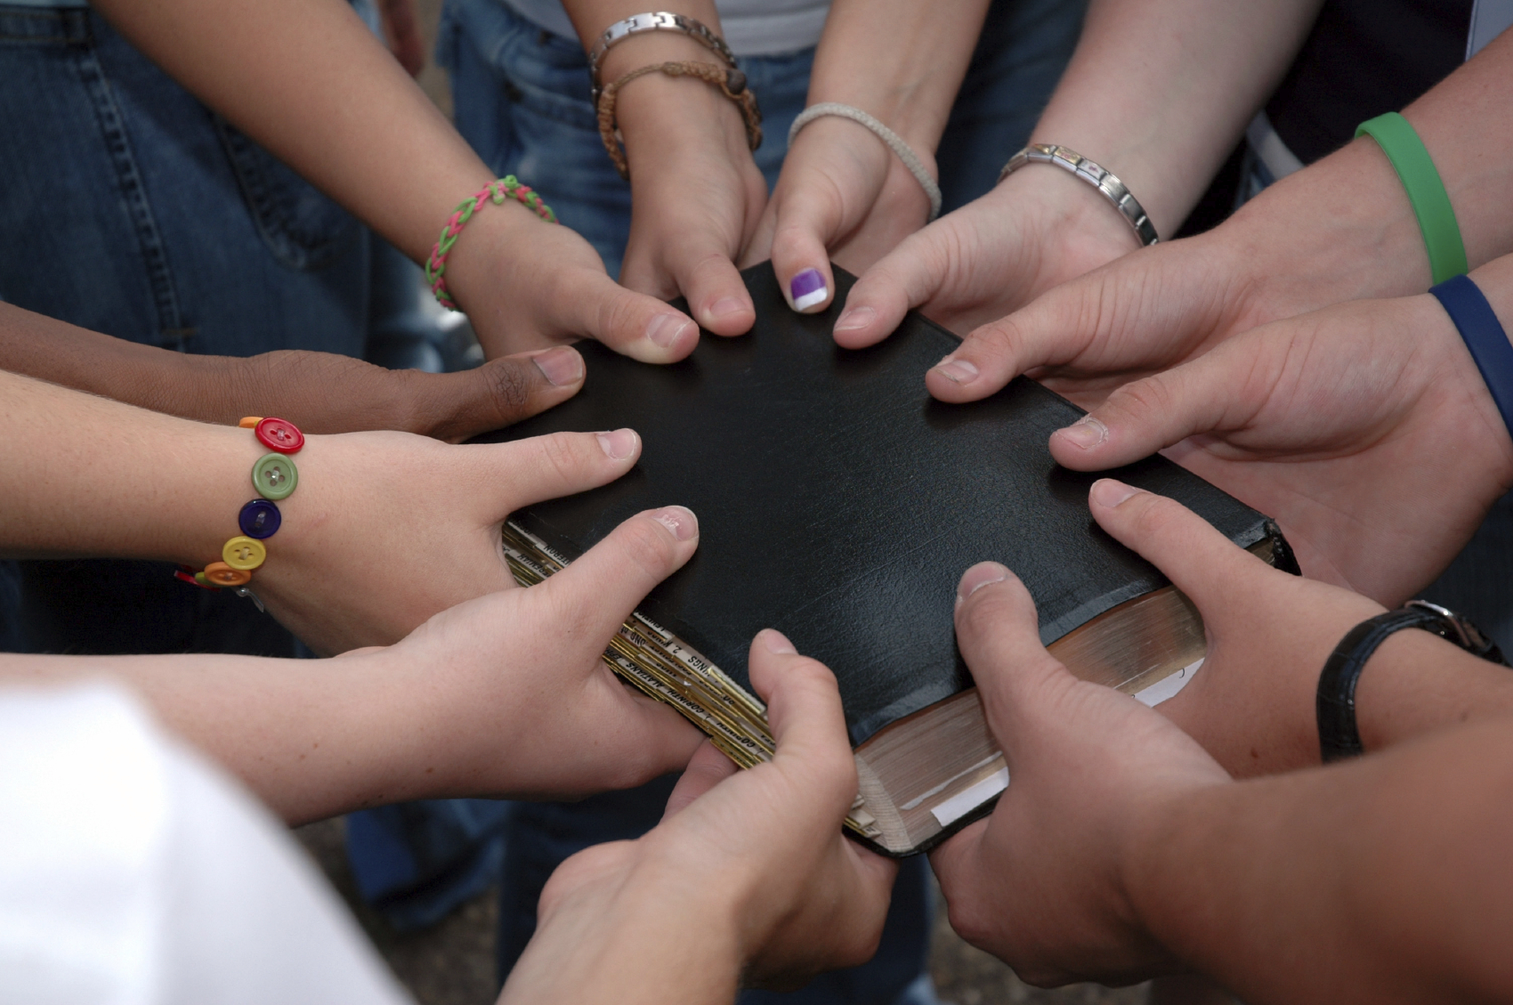

Flyer 10
Q. What river was Jesus baptized in?
Q: Who was Jesus’ cousin’s name?
Q. What was the first miracle of Jesus recorded in the Bible? How many others can you list?
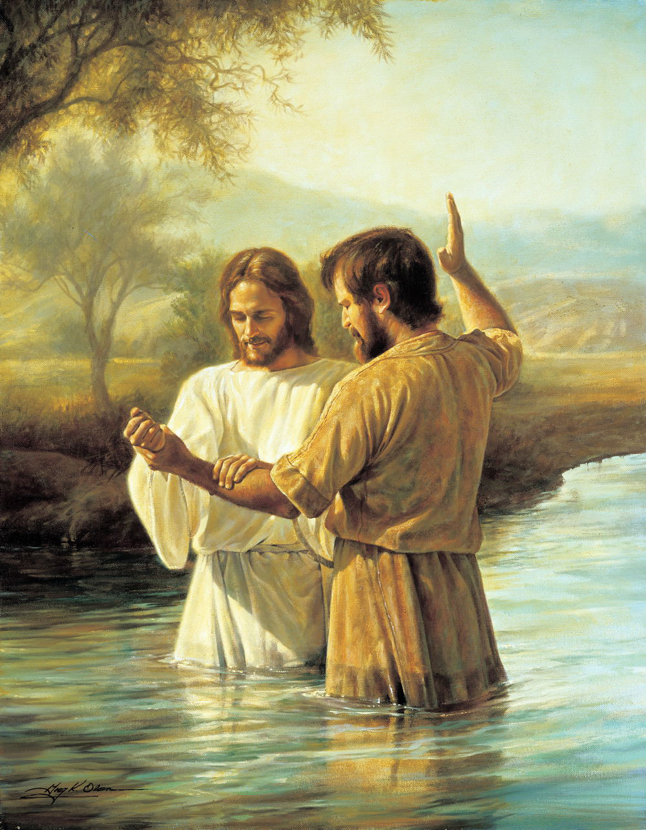

Flyer 11
Q. What kind of work did Zacchaeus do?
Q: What did Zacchaeus do to see Jesus?
Q: Where was Jesus going with Zacchaeus?

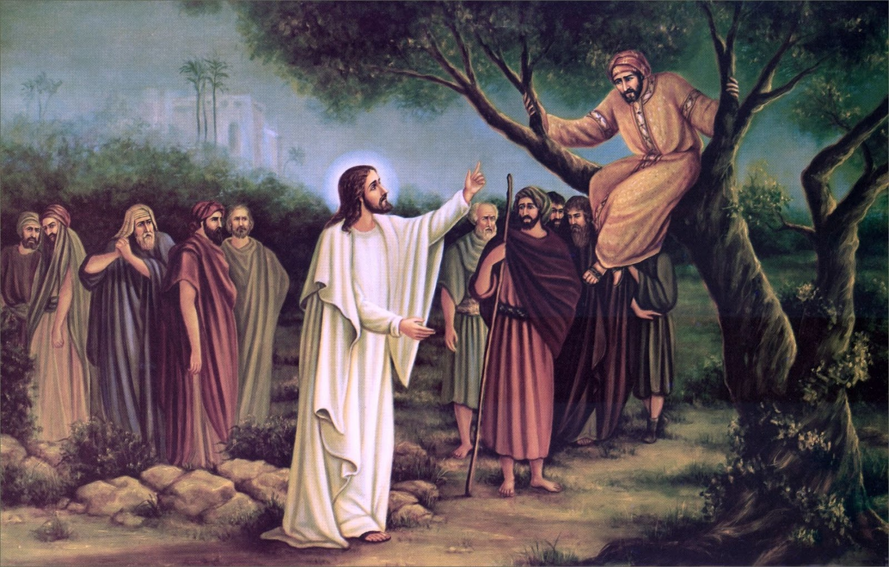

Flyer 12
Q. When Jesus was on the Mount of Transfiguration, who were the Old Testament men who appeared with Him?
Q: Who did Jesus take with him to the Mountain?
Q: What did God say about Jesus at this time?

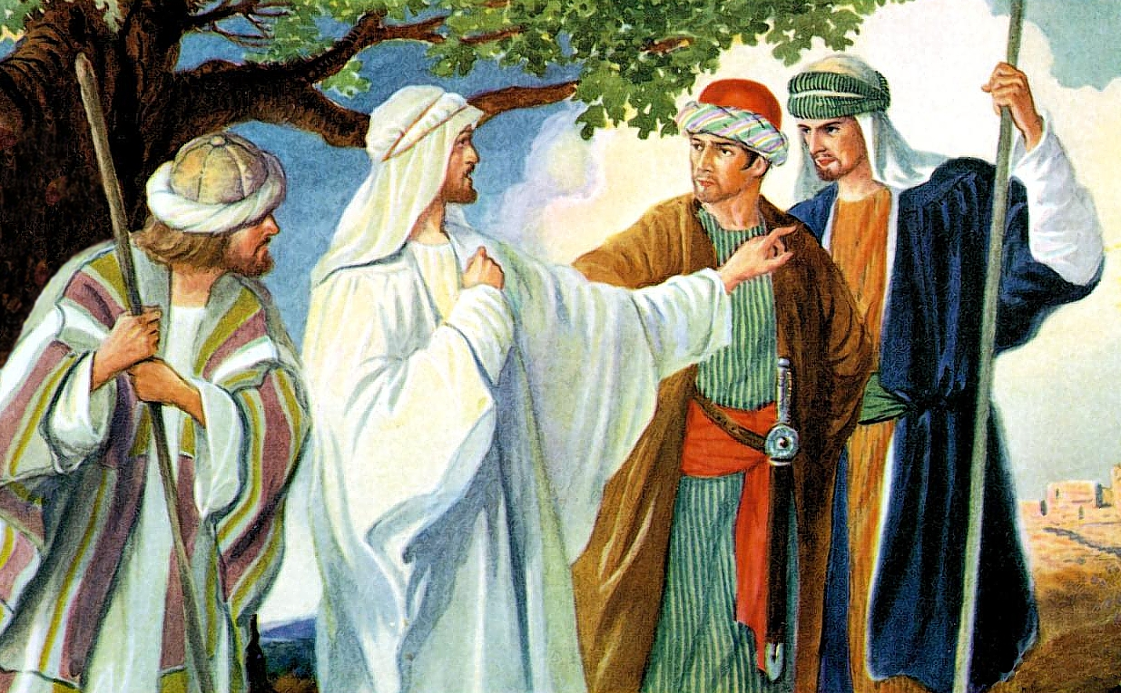

Flyer 13
Little House on the Prairie often shared Christian beliefs and story lines.
Q: What are the names of the Ingalls’s biological family?
Q: What was the name of the Reverend?
Q: Where was the church located in Walnut Grove?
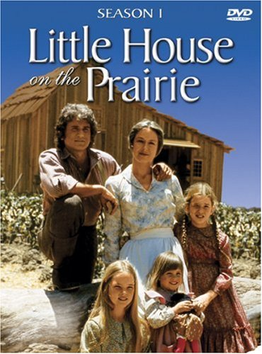
Flyer 14
The Walton’s often shared their Christian beliefs and story lines.
Q: What are the names of the Walton family that lived in the white house?
Q: Who was the Narrator of the Walton’s?
Q: Who was one of the Walton’s Reverends?
Q: Who did the Reverend ask to preach a sermon too while he was on his honeymoon?
Q: Who tried to help this person by writing a sermon?

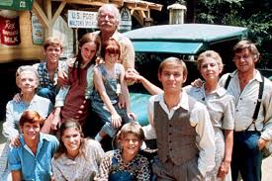
Flyer 15
In many episode’s, Andy Griffith shared Christian themes and storylines.
Q: What are the names of some of the main characters from the show?
Q: Who played the piano in the church?
Q: What church song was sung by Barney and Andy on the front steps?
Q: In the 4th season, a traveling preach named Dr. Breen delivers a sermon called ‘The Sermon for Today”…what was it about?

