Adoption Made Single? By Kris Swiatocho/Linda Nicholls

While in the UK on tour last month, I met a wonderful lady named Linda Nicholls. She was singing at a women’s conference in Plymouth. We sat across from each other at a leaders lunch where she shared the most amazing story of blessing after so much pain in her life. A story of hope, of triumph, and of love.

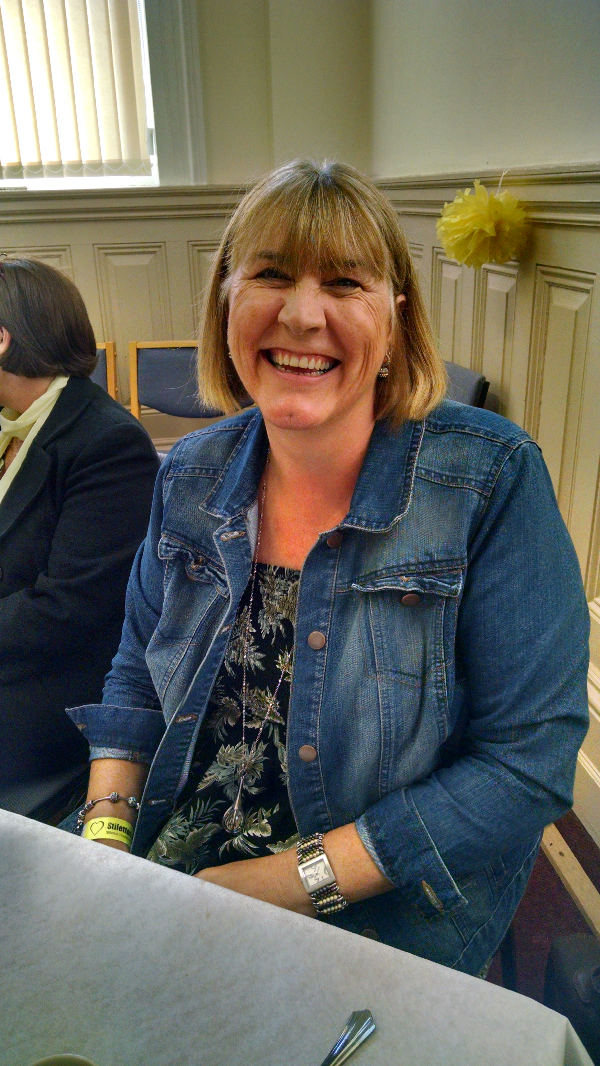
Q: How long were you married?

I was married for 18 years. We were both Christians.

Q: Why didn't you have any children (if you are wiling to share)?

We both agreed that we would wait for 5 years to enjoy being together before we started a family. It became clear however that the marriage was not good after this time so bringing children into an unhappy situation did not seem fair.

Q: Have you always wanted children?

Yes always.

Q: Once you became divorced, what was your experience as a single woman?

It was difficult, as many had known me a one half of a couple. Some friends drifted away, but new friends came who had been through similar situations and they became an incredible life line for me. Churches, even though there are many many broken marriages unfortunately, still seem to struggle with divorce. I had a very gracious Pastor. I am and was a worship leader at my fellowship. When my husband asked for a divorce and the marriage was clearly over, I went to my Pastor to tell him of my circumstance and to ask if he wanted me to stand down from my public ministry. He very gently asked if I was ok. Said how very sorry he was that I was going through the heartache, and then suggested I carry on but if I ever felt I needed to step away for a season to tell him and he would understand. On hindsight, that was such a gracious and perfect answer to my situation. My home, marriage, identity...all shaken. I felt as though satan was trying to take everything.....but he couldn't affect my salvation and he couldn't take my worship! Standing and leading others helped me keep rooted and focused on God. I often thank God for such kind, gracious and wise council from my Pastor.

Q: At some point in time, you wanted children. Did you think it would be best to be married again? Why or why not?

At first I needed to heal from my breakup. Then.....well there have been no offers! I guessed that into my forties, even if a relationship did start, and we did get married, that time would be against me ever having birth children.

Q: When and why did you decide to adopt? Did you think of foster care first?

I decided two years after my divorce. My mother had been adopted so it didn't seem a strange or weird concept. I had seen how being brought up in a Christian family had transformed my mum's life. She often says in her testimony the day she realized her true worth in God. Not someone unwanted, but a child of the Most High. Adopted twice! Once in the natural, and then by God himself! It truly turned her from being a painfully shy woman, to being a strong daughter of God, knowing she had a future and destiny. I guess that was a good example to follow. I was nervous. I had a lot of questions. Was this how God planned family? A divorced middle-aged woman adopting and raising children single-handed? Then a few things hit me. God adopts us. God places the lonely in families. It also struck me that children being left, abandoned to a system that doesn't bring safety, love, stability and longevity isn't right either! I was able to have a period of time to think about my decision when I was matched with my two children. I kept asking God to show me how I could possibly be all I needed to be, both mum and dad, to these kids when I was just one person. God reminded me of Psalm 68 v 5 He is the Father to the fatherless. I could be a single parent as, I believe, He promised to be a Father to my children. I didn't consider foster care. If I was to consider this, I wanted the children to permanently and forever be loved and part of my family. My children....forever.

Q: Please share your experience of the adoption process from a single women's perspective?

The process was quite intrusive understandably. They spoke to friends and family, made sure I was financially stable. I had to have a medical. I have to say though; it wasn't too uncomfortable as the long-term goal was always in sight.

Q: What ages are your children?

They are now 16 and 13. They were 7 & 10 when I adopted them.

Q: How has raising 2 children, without a father been? Do you have a father figure (friends, uncle, your father, etc.) in the lives? Do you have support?

(See above for my initial concerns). It is not easy raising children. Period! It is especially challenging on your own, and additional challenge when your children have had an uncertain start to their lives. I did not enter this lightly. I needed to make sure I had the support of my friends and family. In particular, I needed to know from my male friends that they would help in being seen as positive role models for my children. I was concerned specifically for my son that he would get the in put he needed. He had not had a very positive time of it until his wonderful foster careers. His self-esteem was rock bottom. I have had fantastic help from all of my support network. I feel my church family has demonstrated just that...family! I feel my two have been raised by a community of people not just a single women. I see in him now such possibilities. I am immensely proud of both of my children. Kind, caring, helpful, thoughtful and so loving. My heart nearly burst when they both individually gave their hearts to the Lord. I felt not only had they been given a forever family in the natural, but a spiritual forever family also. I also saw the miracle of lives, which could have been so different if satan had continued to have his way!

Q: What did others think of your decision to adopt? Your church?

To be honest, no one seemed surprised. Everyone was behind my decision. In Fact, since I adopted, some of my friends have adopted/fostered. Sometimes our decisions are like ripples in a still pond. We don't realize the actions we take sometimes affect change in others. My church has been fantastic. We have had Adoption Sunday at church where we celebrated and embraced the concept of adopters. God was the first of course adopting us into His family. My children took part in a video telling of their experiences. My two have always been very open about their situation. It is just a fact of history but does not define who they are. They are wanted. They are loved. They have a future and a hope. They belong.

Q: So many singles struggle with wanting kids but do not see marriage in the near future. What advice would you give to these women and men in relation to this?

Adoption is an option. Think and pray. Ask friends and family what they think and how they could support. There are thousands of children who desperately need love, stability, safety, boundaries, consistency.........family (forever)!
I struggled with the concept of single parenting until I realized how many children are waiting for just this......family. Is it right to adopt as a single person? I think there is a different question which supersedes this one.......is it right to leave children desperate for a home and family when you could be the exact parent they need? There are children who specifically need one parent due to the circumstances, which resulted in their adoption. I don't know if I am a 'perfect parent'. I don't know if they exist. But I do know I am perfect for my children and they are perfect for me. We are a family.

Q: If you could do things over (adoption), is there anything you would do different or suggest for someone else?

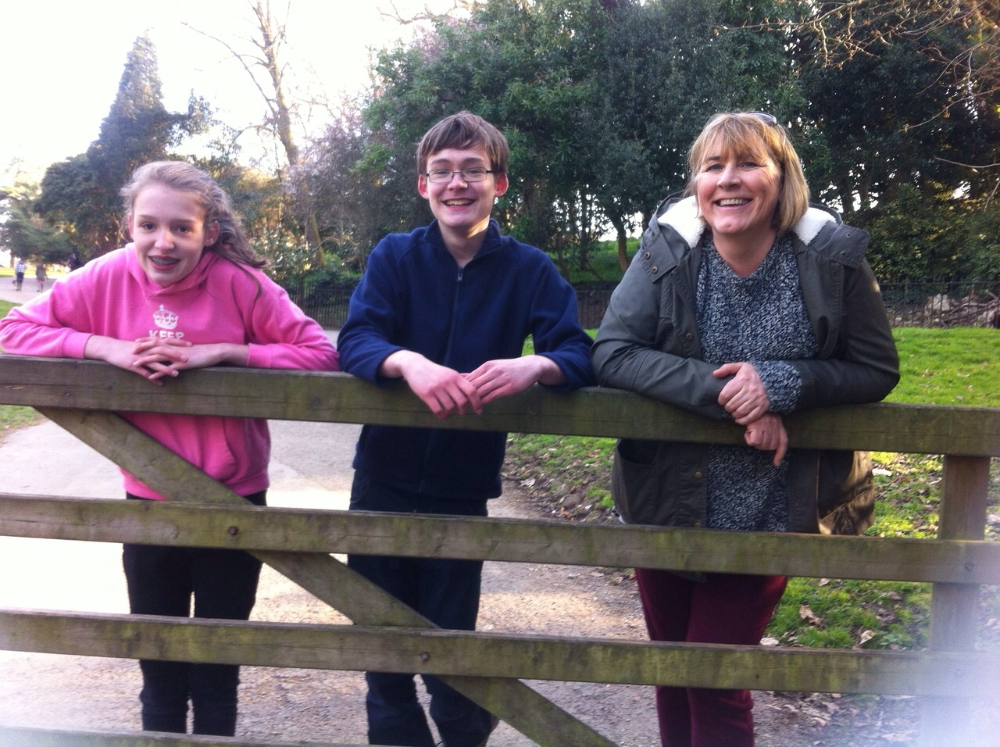
I don't think there is anything I would do differently.

Q: How has God influence all the questions/answers above?

I think this is the most prayed about decision I ever made as it affected so many people. My children continue to be the people I pray most about. Parenting is not an easy endeavor. There are so many times I stop and thank God for how my life took a turn for what seemed like the worse. However, what was meant for harm God turned for good. My divorce enabled me to rethink my life and led me to be a mum to two fantastic kids. They have brought me tears, sleepless nights and so much pride that at times I think I can actually feel my heart swell. God is indeed good.

To learn more about adoption in the UK, or jus to talk with Linda, contact her at : linicholls@me.com

