5 Reasons Your Church Should Serve Single Moms
May 17, 2012 By Jennifer Maggio 4 Comments
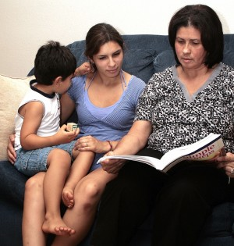With an estimated 15 million single mothers in the United States and numbers increasing daily, it is imperative that the local church have a thriving single mothers program. It is estimated that 67% of single mothers do not actively attend church. As the church – the body of Christ – this should pain us. It should keep us up at night. Many single mothers do not feel they belong in the house of God. The fear that they will be judged. They are concerned that others will not understand their journey.
It is important that we understand that single mothers, like all of us, desire genuine connection and fellowship with those who best understand our situation. We all want to know that someone has walked the path we are currently on, and not only survived, but thrived.
So, why should we formalize a single moms’ ministry within the walls of our church?
- The Bible tells us so. We have been commissioned with certain duties by the Lord. Psalms 146:9 informs us “He cares for the widows and orphans.” Luke 14:13 challenges us to “invite the poor.” 1 Timothy 5:3 advises us to “take care of the widow.” The widow, many times, is the single mom. The orphans are left by a single mom. The poor are often single moms.
- Single parents are one of the fastest-growing sects of our population. What better way for our local churches to grow than to conect with the 9 million unchurched single mothers in the country? This respresents more than 20 million women and children and they are in our neighborhoods, grocery stores, and schools.
- Single moms need more than just a Christimas toy drive once per year for her children. They appreciate that sort of thing, but she desires sustained connection with the house of God. She longs to learn more about financial stewardship and parenting effectively. She needs long-term fellowship with other single mothers in similar seasons of life. She wants to know that she is not alone.
- A single moms’ ministry is NOT the same thing as a singles ministry. Singles ministries are co-ed environments. Many single mothers are recently divorced or vulnerable and need a private support group for women only. This allows the freedom to express concerns and hardships sans the added pressure of the opposite sex.
- And perhaps the most important point – single moms ministries DO NOT condone unwed pregnancy or divorce no more than addictions’ ministry condones drug use. We know God’s word calls us to live in sexual purity and that marriage was intended to last forever. We know that and embrace that, as believers. However, we cannot ignore that there are millions of single parent families that exist today. We must address the needs of those within our community who find themselves parenting alone.
Our mission on this earth, as Christians, is to populate Heaven and plunder Hell. We are to seek out the marginalized, hurting, broken, and poor. We are looking for those who do not know the love of the Father that we know. They do not know the Jesus that forgives all sin, erases all record of wrong, and loves unconditionally.

