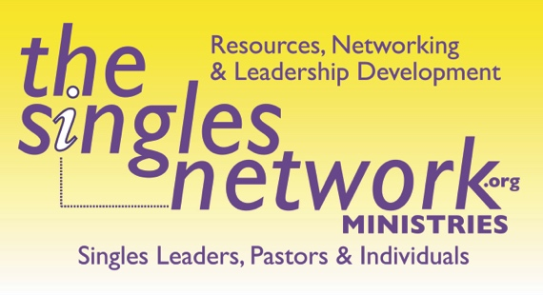

WE DON’T HAVE ANY SINGLES???

Often I hear this from pastors. The reason is that most churches either do not understand what is considered a single adult or simply do not believe they are called to reach them. I mean, for 2000 years the church has been led by a married man with the average age of 40 with 2 kids. While yes, marriage is important….I love that most of our pastors are married, however, to ignore this huge other demographic is crazy.

Over half of the US is now single. So how can we quickly reveal this to our churches? Please know, the goal of this experiment isn’t to say our pastors aren’t working hard to minister or that our church is bad. It’s simply to show that there are many people in your church who are not married, in various aspects of singleness. And while some singles are happy where they are in your church, most of them would love a community geared towards them, where they are..whether young adult single, single again, widowed, never-married but wanting to be married, single parent, etc. A community that would bring others living life where they are living life. A community that could reach so many more for your church.

INSTRUCTIONS:
An easy experiment you can do in your Church to show how many people are “not married”—(single) and how little resources there are to reach them by way of those leading or ministering to them. This should be done on a Sunday morning to all services (due to some churches services vary in demographic focuses). This takes less than 5 minutes to do.

1. Ask for all those that are not married over 18 stand up. Have everyone look around. Then have them sit down.

2. Now ask that everyone else stand up over 18. Then ask these questions:
-If you have a parent who is not married, sit down.
-If you have a child who is not married, sit down.
-If you have a grandchild or great grandchild who is not married sit down.
-If you have a cousin who is not married, a niece, a nephew, an aunt, uncle, sit down.
-If you have a neighbor who is not married sit down, someone you work with, sit down.

By this time, everyone should be sitting down. Although I have had 2 situations where people were still standing but it was due to not being able to hear what I was asking. In one case I simply went down to the person, introduce myself, told them I was single and they now knew me and to sit down. Lol.

Then say, if you are in singles ministry of some kind, lead divorce care, griefshare, young singles, college, single parents, etc. stand up. There should only be a handful. Then say...

See, everyone is effected by singleness. We need to have more support for this area of ministry. If you are a married adult, you could mentor, offer childcare to a single mom or dad, host a singles gathering in your home, etc. You could be a prayer warrior for those wanting to be married. What you are YOU going to do to make a difference. Because unless you die when your spouse dies, you too will be single too.

Start today to make a difference.

Optional endings: use this as a platform too..
-Start a singles or young adult single ministry
-Promote a singles lunch or other gathering to reach them
-Include this in a “Single Sunday” with a sermon towards singles, singles ushering/greeting, single testimonies, etc.
-Start divorce recovery or other specific single adult focused ministry
-Start a www.prayforamate.com group
-Train leaders to lead singles
-Say thank you to those who are serving in singleness
-Raise support to send single adults to a retreat, training, mission trip, etc.

For more information on how your church could do a better job in reaching this huge demographic, give Kris a call at 919.434.3611 or Kris@thesinglesnetwork.org.

