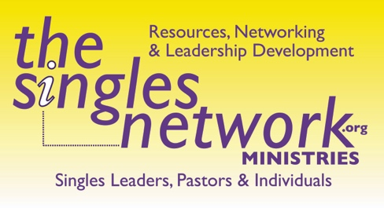

By Kris Swiatocho, Director, The Singles Network Ministries

Whether you are teaching singles in your Sanctuary, in Sunday school, a small group, at an event, on a mission trip or even by zoom (or other media service), the topic needs to be relatable so that singles of all backgrounds and life-stages can:
- Draw closer to God
- Become aware of what needs to change to become more like Christ.
- Be able to take notes (avoid fill-in-the blank; allow people time to listen and take personal notes)
- Be able to discuss the message/lesson if not immediate, soon after with a group or each other.
- Include the steps of salvation if at all possible.

TEACHING TOPIC IDEAS:

PURPOSE
- Salvation
- Having a quiet time
- Prayer life
- Spiritual gifts
- Walking with God
- Hearing from God
- Knowing God’s will
- Forgiveness
- Trust
- Dealing with the past/future
- Personal health/taking care of yourself

DATING:
- Should I date
- Should I only date if I think they are the one
- Baggage/dealing with past
- Trusting someone when you have been hurt or lied too
- Defining dating
- Becoming the right person first
- Accountability in Dating
- Boundaries
- Missionary dating
- Learning about the opposite sex
- How long should I date
- Is dating only for marriage
- What does the bible say about dating
- When to take things to the next level
- Engagement: Defining engagement including when you should get engaged, what it looks like, how long is healthy, accountability etc.
- Sex
- Attraction/same sex attraction concerns

FRIENDSHIP:
- Being friends with the opposite sex
- Being friends with the same sex
- How to start a friendship
- What to look for in friendships
- How to end a friendship
- Types of healthy friends
- When to ask for accountability in our friends
- Dealing with difficult friends
- Dealing with co-dependent friends
- When to date a friend
- How to fix a broken friendship

DESCIPLING/MENTORING
- When to Disciple
- What makes a great disciple
- What are ways to mentor
- Should I be mentored
- What are missions
- What is evangelism
- How to share your faith
- How to lead someone to Christ
- Should I become a leader, teacher, or missionary
- What makes a great leader?
- When and how should I serve

SINGLE PARENTING:
- How to raise kids alone
- Involving my kids other parent; grandparents
- Should I date?
- How do I date?
- Budgeting on a single parent income
- Raising kids to love Jesus
- Parenting tips
- Problem solving
- Helping kids when they are hurting

DIVORCE:
- Should I get a divorce?
- Biblical grounds for divorce, did I have that
- When can I start dating
- Separation is the same as being divorce, right
- How to have boundaries with my former spouse
- My In-laws are now my ex-laws; what do I do
- How to figure out my finances
- How to long does it take to heal
- Should I be in a singles group
- Should I take divorce care

GRIEF/LOSS:
- What is loss
- What is loneliness
- How long is too long to grieve
- Should I take my wedding ring off
- When should I get counseling
- When should I join Grief Share
- When should I involve my family in my grief
- What is depression?
- Is it ok for a Christian to get depressed and take meds

FAMILY LIFE:
- What does a healthy family look like
- How much time should I spend with my kids? With my parents siblings
- What is normal family conflict
- How much should I talk to my family about God and when
- How should I regulate TV/Computer/Phone with my kids
- Taking care of elderly parents
- Handling finances and budgeting

FINANCES:
- What is a budget
- How much should I be saving
- How do you invest? What does that look like
- How much should I tithe
- What is a will, power of attorney and do I need it?
- Do my family or friends know what my final wishes are
- Do I need a medical guardianship? A living will? And if so who should it be?

