   Lay by the Pool Visit the Lakes Shop the Landing

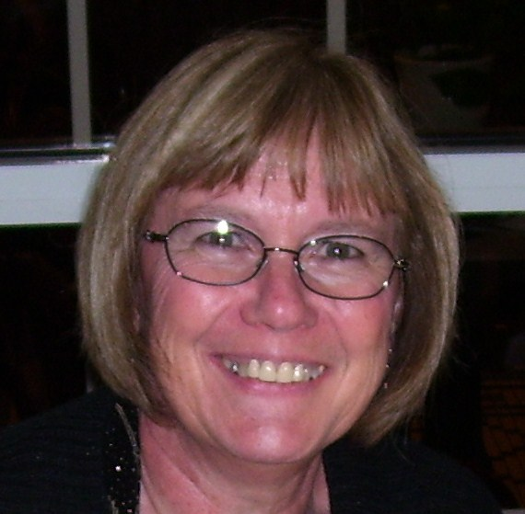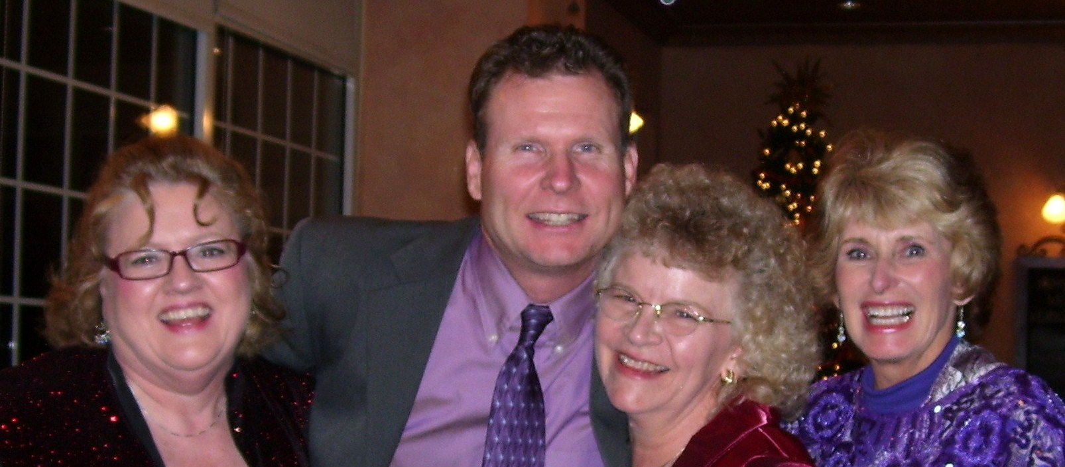
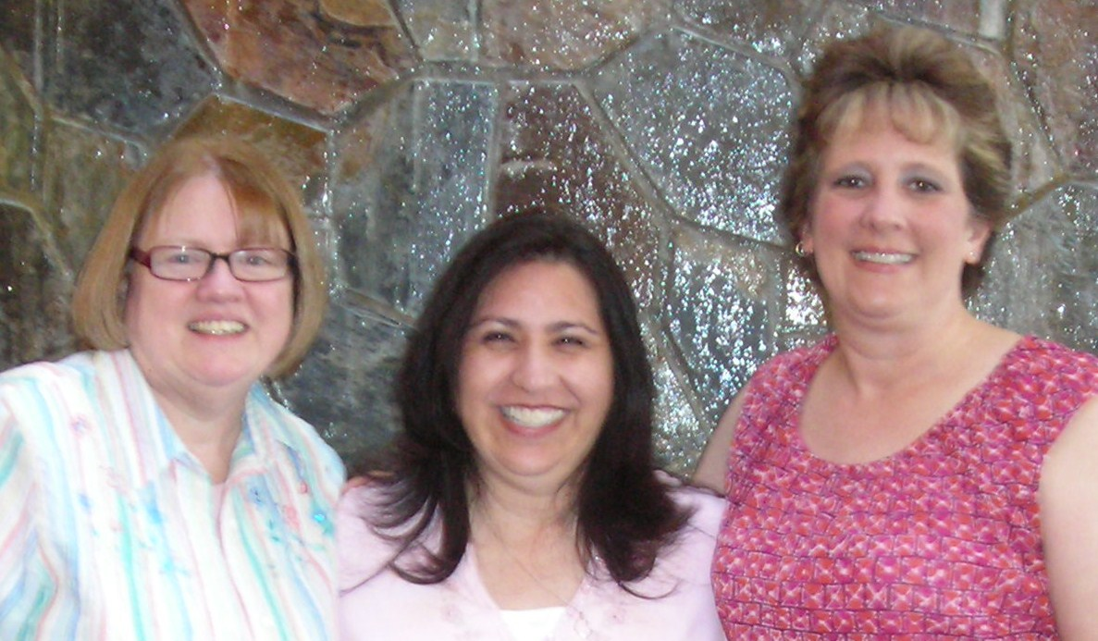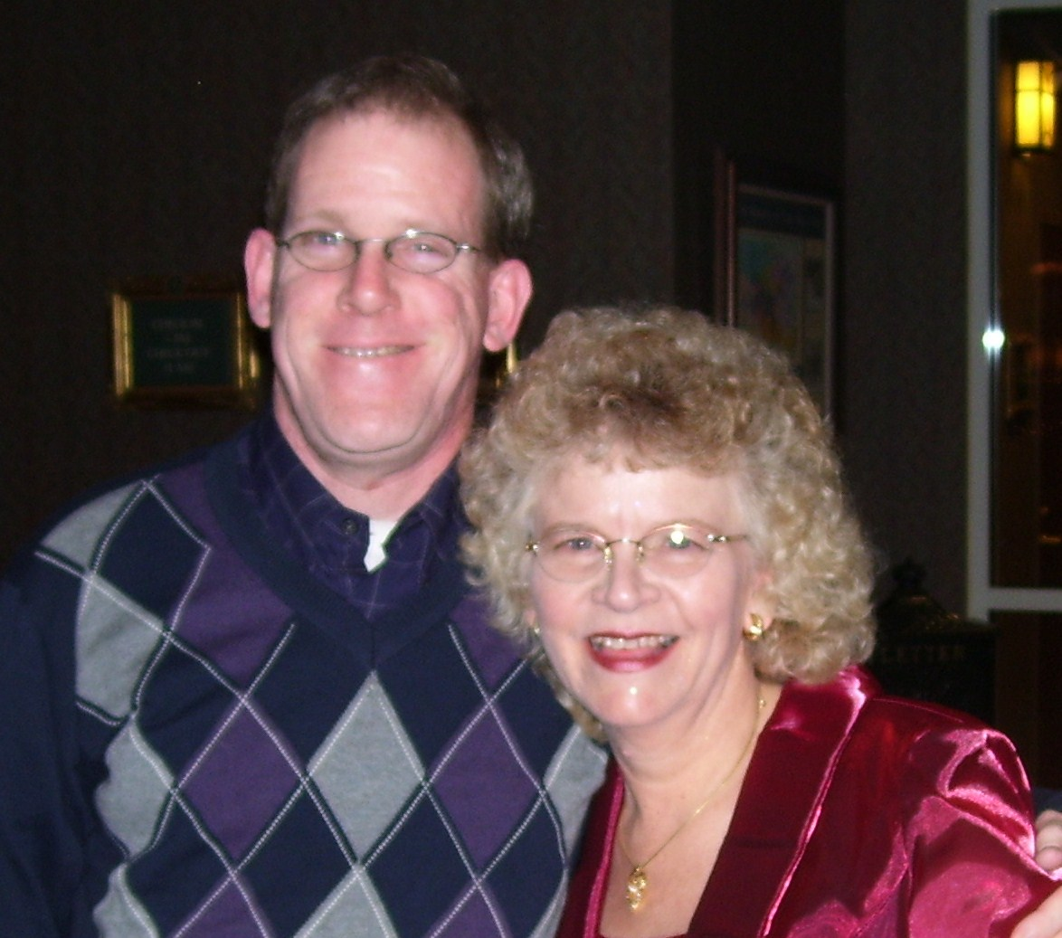

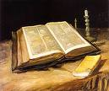.. 

Retreat sponsored by the

Joplin District Singles

February 25 – 27, 2011
Stone Castle Resort
3050 Green Mountain Dr.
Branson, MO

Speaker: Timothy Mark


Workshop Leader:
Dr. Dan & Diane Holmes
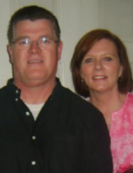

Registration starts at 3:30 pm on Friday, February 25
registration information: Name:____________________________
Address:___________________________
__________________________________
Phone Number:___________________________
Email:_____________________________
Home Church:___________________________
Roommate:________________________
Male____ Female______
Age Group: 20-30___ 31-40____
41-50___ 51-60____ 60+_____

Single Parent____ Divorced____ Widowed_____ Always Single____
Any special needs (handicapped room, special diet, etc)

Cost $109* per person, 2 in a room *Contact Donna for cost of private or more than 2 in a room at: ho1mesdg@aol.com
Send $50 deposit by Feb 8th to:
Monika Easterly, 7051 E Farm Road 48, Strafford, MO 65757
Make check out to Joplin District SS Ministries

It’s hard to define who Timothy Mark is. He is a singer. He is a songwriter. He is an author, preacher and a conference speaker. But if you ask him to define himself he will tell you that he is simply a communicator. And he will use whatever it takes to get the message across.
Timothy Mark brings to the ministry a desire for the audience to experience genuine relationship with God. Mark leads an audience to the place where they realize a growing relationship with God is the only thing that will fill the emptiness in their lives. Songs such as “What if There’s a God?” and “The Church across the Street” reach out to the individuals in the Christian community with a call to live out what they say they believe.
Mark’s newest CD release “What I Believe” is one of the tools he uses to communicate that truth. The CD production was completed in early 2005 and has been received with high acclaim for its lyrical depth and musical production. Previous projects include The Nature of Love, an instrumental album which showcases his piano artistry and focuses on the love relationship we have with God. The Missing Part album, another previous release, features Timothy's song writing talent and vocals with songs that are encouraging and uplifting. The website also features free downloads of several of his messages.
In a world searching for the truth, Timothy Mark has something to say. And people are listening.
Dan and Diane Holmes has worked at Lighthouse Counseling Center in Jonesburg, AR for the past 10 years. Dan has a Phd in Counseling and Diane has a MS in Counseling. They have been working in the field of psychology and counseling for the last 26 years. Dan’s work has taken him from working in an inpatient unit with the severely mentally ill, to teaching at a university as a professor of psychology and counseling to his current position. Diane has worked inpatient and been director of a geriatrics unit.
Diane and Dan, have received over 150 hours of specific training in working with couples. With their training and practical experience they have learned communication is a key when working with people in counseling. Diane and Dan have been able to use this knowledge in presentations and workshops over the last several years. They have developed communication activities to help people learn the positive and negative effects of communication. They are excited to share this information with singles and share their vast information learned and experienced over their 32 years of marriage.
Diane and Dan have four children, three daughters and one son.

Directions to Stone Castle Hotel
www.bransonsettleinn.com
West Highway 76 to Grand Palace. Turn left on Wild Wood Drive. Turn right on Green Mountain Drive and look for the gleaming white castle up on the hill.

