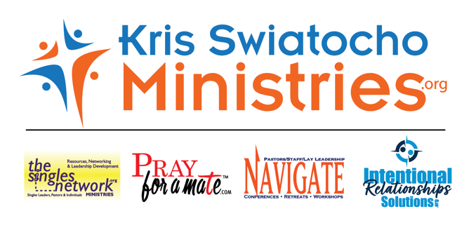

Greetings, friends; 2023 has been an incredible year in ministry. I am in awe that God continues to use me. I am so grateful for your prayers and gifts. Your donations have helped me continue the work God had called me to do,
such as:

• Developing leaders in the US, Europe and Uganda
• Offsetting ministry expenses and/or needs in Greece, Slovakia, Albania, UK, US and Uganda
• Creating training resources to help start and grow the ministry
• Online resources such as keeping the websites and social media up to date and relevant; writing articles and developing tools
• Zoom and Live Facebook events for training and teaching, consulting
• Book/Bible study updates
• In-person events: Workshops, Conferences, Retreats
• Plus, marketing, admin, and travel expenses as well as personal needs

HIGHLIGHTS OF 2023
• First singles and ministry to singles Prayer event here in the US and Europe; development of 21-Day Prayer Guide
• (3) Pray for Mate Online Zoom Events
• (6) Overcomer Zoom events with Cory Nichols
• (52) Live@5 Podcast
• (12) Newsletters that included leadership and general articles plus other writers
• 9th Labor Day Singles and Leaders Retreat; over 250 from all over the US in attendance
• (3) Community Spotlights with the Light FM; (3) WGGS TV Programs
• (2) Premier Radio UK interviews
• Solo “Singles Offering Life to Others” Reunion Event (where I got my start in singles ministry)
• Led several Bible studies in person and online of the Intentional Relationships for Singles
• Sent 100 Bible studies to Uganda for ministry there in several churches
• Hired to speak on two cruises, one this month and one next summer to Alaska
• Spoke all over the US again this year
• Spoke in 4 Countries and conducted training and events in Europe. These events were focused on leaders, pastors, singles, the whole church, single moms, and youth/young adults.
• Spoke at the National Convention to 400 Pastors and leaders for COG on singles ministry
• Plus, I got to witness many salvations and recommitments to Christ, new ministries started (women and singles), and doors open in churches that had previously shut their doors to singles ministry

So, thank you for your continued belief and support of me. Your gifts are multiplied through me. As you gave to me, I was able to help others who were also able to help others. Thank you!

Psalm 96:3 Declare his glory among the nations, his marvelous works among all the peoples!

