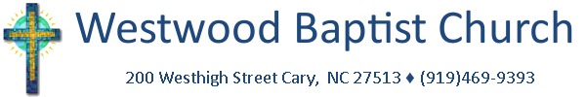
HOSTS
A SINGLE ADULTS SEMINAR
for divorced, widowed, and never married singles
SATURDAY MORNING, FEBRUARY 8, 2014
in the Church Fellowship Hall
THEME: “Our Identity”
Guest speakers include:
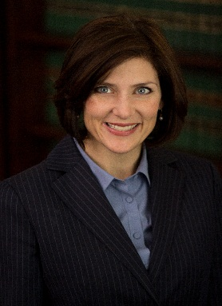 | Caroline Farmer, Deputy Director  Victims and Citizens Section  NC Attorney General’s Office  Topic: “Identity Theft”
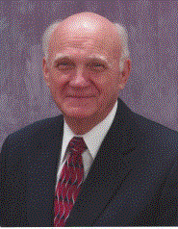 | Dr. Talmage Williams  Retired Pastor and  current member of Westwood  Topic: “Our Single Identity”
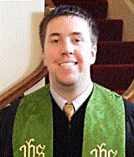 | David With  Minister with Students  Hayes Barton Baptist Church, Raleigh  Topic: “Our Eyesight: Overcoming the Barriers and Begin Living an Extraordinary Life by Fixing Our Eyes on Jesus”
For more info and to pre-register, please contact the church at 919-469-9393.
Registration is $15. Make checks payable to Westwood Baptist Church.
Registration starts at 8:30am, program begins at 9am and continues to 1pm.

