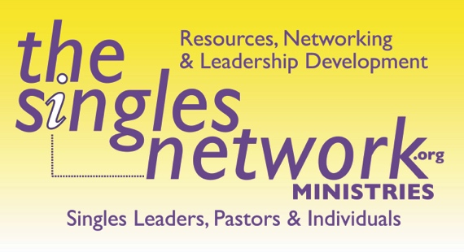

WE DON'T HAVE ANY SINGLES…
It is often what I hear from pastors when I ask them if they have a singles ministry. So why do churches not have a singles ministry? Most churches either do not understand what is considered a single adult (is it someone in college, twenty-something, someone whose parents are alone, widowed, divorced, etc.) and, as a result, have no idea how to reach them. Or in most cases, due to a lack of resources and leadership do not believe they are called to reach them. I am not saying they don't feel led to reach people for Christ; it's just to focus on this one demographic seems unnecessary to them. For 2000 years, the Church has been led for the most part by married men, the average age of 45, with two kids. And because of this, they focused more on who they are—traditional families with kids. I totally understand this. Often when I teach in the pulpit to all audiences, as a single, I have to remind myself to share examples that include marriages. Why? Because almost all of my ministry is focused on where I am as well, a single adult.

If you are a pastor, a leader, or someone married and reading this, please know that over half of the US population is now single. This means they are not married, 18 years and older. But our churches do not reflect this percentage. We are missing out on reaching an incredible group of people. People can help build the Church by reaching the lost, discipling, training leaders, etc.
So, how can we help our churches with this understanding? And understanding that would create a desire to reach single adults. A desire to build leaders, start Bible studies, including ones to help equip singles who want to marry, offer counseling, divorce support, grief support, etc.

ONE SOLUTION:
Please know the goal of this experiment isn't to say our pastors aren't working hard to minister or that our Church is bad. It's simply to show that many people in your Church are not married in various aspects of singleness. And while some singles are happy where they are in your Church, most of them would love a community geared towards them, where they are; whether young adult single, single again, widowed, never-married but wanting to be married, single parents, etc. A community that would bring others living a life where they are living life. A community that could reach so many more for your Church.

INSTRUCTIONS:
An easy experiment you can do in your Church to show how many people are "not married"—(single) and how few resources there are to reach them by way of those leading or ministering to them. This should be done on a Sunday morning for all services (due to some churches' services varying in demographic focus). This takes less than 5 minutes to do.

- Ask for those not married* over 18 to stand up. Have everyone look around. Then have them sit down.
*We say not married because even among single adults, they often label themselves young adults or widowed, etc., vs. single. The term single has many definitions. It's up to the Church to help define it and celebrate its value.

2. Now ask that everyone else stand up over 18. Then ask these questions:
-If you have a parent who is not married, sit down.
-If you have a child who is not married, sit down.
-If you have a grandchild or great-grandchild who is not married, sit down.
-If you have a cousin who is not married, a niece, a nephew, an aunt, uncle, sit down.
-If you have a neighbor who is not married, a friend, or someone you work with, sit down.

By this time, everyone should be sitting down. However, I have had two situations where people were still standing, but it was due to not being able to hear what I was asking. In one case, I simply went down to the person, introduced myself, told them I was single, and they now knew me and to sit down. Lol.

Then say, if you are in singles ministry of some kind, maybe you divorce care, griefshare, young adults, college, single parents, etc., stand up. There should only be a handful. Then say...

See, everyone is affected by singleness. The harvest is many, but the workers are few. Over half of our country is not married; many are here in this Church and community. We need to have more support for this area of ministry. If you are a married adult, you could mentor, offer childcare to a single mom or dad, host a singles gathering in your home, etc. You could be a prayer warrior or counselor and lead a Bible study for those wanting to be married. What are YOU going to do to make a difference? Because unless you die when your spouse dies, you will be single too.

Start today to make a difference.

Optional endings: use this as a platform too.
- Start a single or young adult single ministry (see www.TheSinglesNetwork.org start)
- Host a singles lunch or other gathering to reach them at your Church or in someone's home.
- Include this experiment in a "Single Sunday" with a sermon towards singles, singles ushering/greeting, single testimonies, etc. Note: While we appreciate our married pastor of 40 years preaching the sermon, it would be much better to have someone single teach or a series of testimonials.
- Start DivorceCare.org, Griefshare.org, CelebrateRecovery.org, Single Parenting ministry, or similar to minister to singles.
- Start a www.prayforamate.com group or https://www.intentionalrelationshipsolutions.org/ study for those wanting to be married.
- Train and equip leaders to lead singles. See the website for the curriculum.
- Raise support to send single adults to a retreat, training, mission trip, etc.

For more information on how your Church could better reach this huge demographic, call Kris at 919.434.3611 or Kris@thesinglesnetwork.org.

