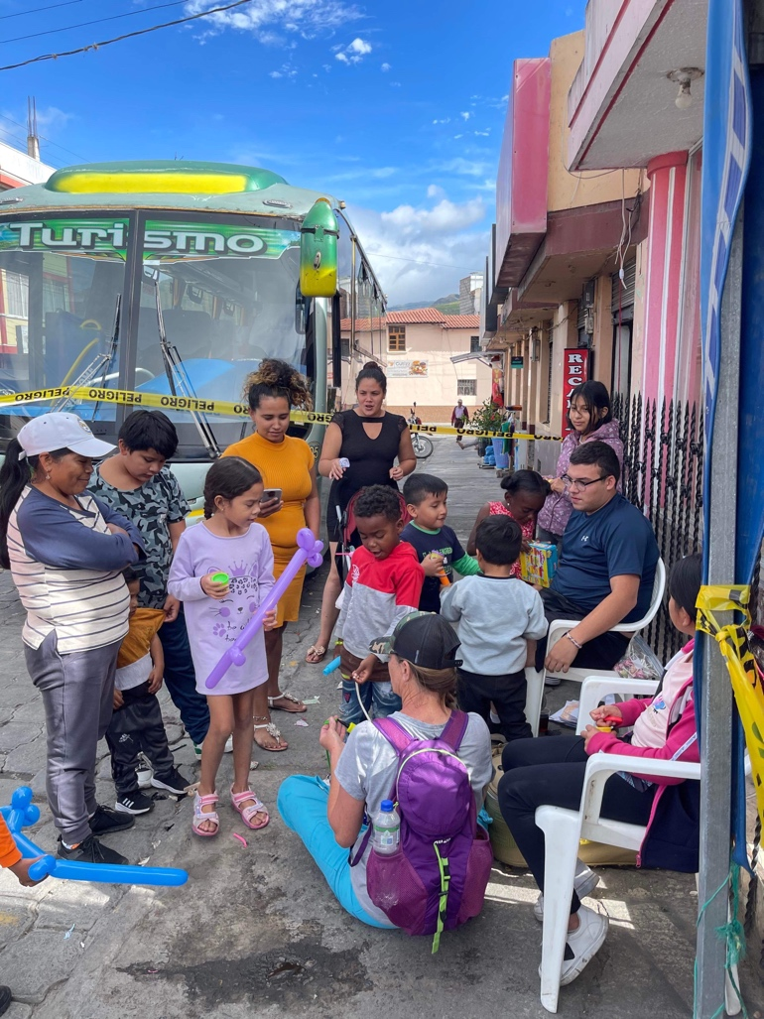
Single Serving in Ecuador for Jesus
by Renee Hermance
I just returned from a fantastic medical trip of 6 days to Ecuador, serving with my church, Grace Community in Marion, NC, and others in the city of Ibarra, Atuntaqui, Amburqui, Utcuqui, and Conocoto. My job was to assist the doctors, including the eye clinic, and help share the gospel.
On the first day, we attended one of the local churches where Pastor Cadena shared the importance of meeting the needs of the people physically and spiritually. We were happy to meet him and hear of his church's work.
On the second day, our team was scheduled to see patients in a particular city area, but the government notified us that they had pre-arranged a different place in the market. We didn't know it then, but we needed permits to set up to treat people, something only the government could provide. We also required police protection. We prayed to ask God for his help in getting these permits quickly and that the police would provide protection. God did not let us down. He answered our prayers and needs, evening giving us more than we asked by some free advertising through a local man who drove a truck around announcing our visit.

This marketplace was a hub for the locals and the perfect place for us to be. The setup went smoothly, and only God could create a space to run this well, giving God all the glory.
During the week, we treated over a thousand men, women, and children, opening the door to share the gospel, and many were saved. I met one young lady, a fourteen-year-old named Miley, who had outgrown her wheelchair. What a joy to give her a new one while sharing the gospel.
One other day I met a young man who saw us ministering at the clinic and decided to visit our evangelistic tent. One of my team members started to talk with him about why we were in Ecuador and how God wanted to meet our physical and Spiritual needs. Then God opened the door for me to share the gospel. At first, he didn't seem interested, and I was like, oh well. All you can do is be obedient to share and trust God for the rest. We then had an open invitation for anyone in the tent to accept Christ. We also encouraged them to join a local church, Verbo Iglesia.
Luke 8:11-15 ¹¹ "This is the meaning of the parable: The seed is the word of God.¹² Those along the path are the ones who hear, and then the devil comes and takes away the word from their hearts, so that they may not believe and be saved. ¹³ Those on the rocky ground are the ones who receive the word with joy when they hear it, but they have no root. They believe for a while, but in the time of testing they fall away. ¹⁴ The seed that fell among thorns stands for those who hear, but as they go on their way they are choked by life's worries, riches and pleasures, and they do not mature. ¹⁵ But the seed on good soil stands for those with a noble and good heart, who hear the word, retain it, and by persevering produce a crop.
We finished sharing with the whole group and were setting up for a new group when the young man came back up and wanted to accept Christ as his Saviour. We were so overjoyed. We went through prayer with him, and he accepted Christ. We then connected him with the local church. I guess he was listening.
On my last day, Dave, one of my team members, brought in a woman who was blind in one eye and the other eye had sun damage. He was looking through our inventory of sunglasses, hoping it would help keep from any further damage. He also wanted to fit her for some readers. Each pair we tried wasn't strong enough until we found the perfect one. She was like Oh!!! And we asked if she could see, and she said very clearly. This, again, opened the door to sharing the gospel.
Psalm 146:8 The Lord opens the eyes of the blind. The Lord lifts up those who are bowed down; the Lord loves the righteous.
Jesus, by example, teaches us the importance of feeding, healing, and coming alongside to reach someone's heart. The change has to be in the heart, but when you can't see, you're using a wheelchair for a child, you have an infection, or you are hungry, you are distracted from listening to God's truth. Once we provide those basic needs, God opens the doors to share.
James 2: 14-18 What good is it, my brothers, if someone says he has faith but does not have works? Can that faith save him? If a brother or sister is poorly clothed and lacking in daily food, and one of you says to them, "Go in peace, be warmed and filled," without giving them the things needed for the body, what good is that? So also faith by itself, if it does not have works, is dead. But someone will say, "You have faith and I have works." Show me your faith apart from your works, and I will show you my faith by my works.
This trip changed me. I am so thankful that I got to go. So whether you are single or married, young or old, it's never too late to go on a mission trip. Pray today, get off that couch, step out in faith, trust God for those doors, and join me next time.
To contact Renee or learn more about her church, Grace in Marion, NC, email her at: rherman1995@icloud.com

