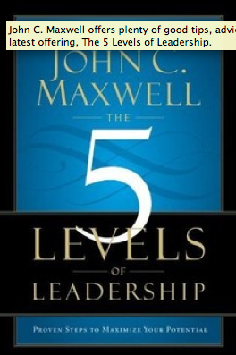
In John C. Maxwell's latest book, The 5 Levels of Leadership, he offers these tips for business, workplace and organizational leaders:
- Good leadership isn't about advancing yourself. It's about advancing your team.
- Leaders become great, not because of their power, but because of their ability to empower others.
- Leadership is action, not position.
- When people feel liked, cared for, included, valued, and trusted, they begin to work together with their leader and each other.
- If you have integrity with people, you develop trust. The more trust you develop, the stronger the relationship becomes. In times of difficulty, relationships are a shelter. In times of opportunity, they are a launching pad.
- Good leaders must embrace both care and candor.
- People buy into the leader, then the vision.
- Bringing out the best in a person is often a catalyst for bringing out the best in the team.
- Progress comes only from taking risks and making mistakes.
- Leaders are measured by the caliber of leaders they develop, not the caliber of their own leadership.
© 2014 John Maxwell
http://thejohnmaxwellteam.com/

