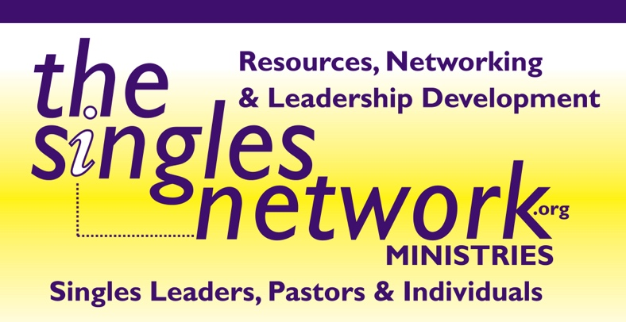

Regardless of size, every church is called to minister to single adults.

To have an effective singles' ministry, you need six things:
- A program designed specifically for single adults that provides them a time when they can build relationships with each other.
- Strong leadership
- A teacher who can lead single adults into the truths of God's Word and encourage the application of those truths.
- Activities that give single adults a chance to interact with each other.
- Bonding experiences (small groups or retreats)
- A positive identity of singles in the church body and leadership.

—Author: Pastor Rich Hurst

